National Senior Classical League
General Assembly III July 26, 2021

Meeting began at: Jamie called the meeting to order 9:18 pm CST

Jamie read the guidelines for the zoom meeting.

Board Officers:
- Jamie Doyle, President
- Rachael Cox, Vice President
- Shandi Burrows, Secretary
- Natasha Panduwawala, Treasurer
- Neah Lekan, Parliamentarian
- Elizabeth Foster, Historian
- Ann Nguyen, Editor

Farm Theme GA’s: Tractor Facts of the Day, Jamie
- The word tractor is derived from the latin word Traho, meaning “to pull”

Farmer(s) of the day:
- Joey Chatelain
- Jordan John Lee

Whizbangs, Shandi
- “I can take it raw.” - Vincent Bianca
- “She was excited to see how much it grew.” - President Jamie Doyle

Officer Reports
- Ann, Editor:
  - Thank you to everyone who stayed up late in the Ear Office last night
  - Please stop by tonight as always
- Elizabeth, Historian:
  - Spotify Playlist looks great! Thank you to everyone!
  - SCL Superlatives form is out, please add to it so we can have as many superlatives to vote on as possible. Tat form will close after this GA
  - The highlight video celebrating everyone this year needs more submissions please! We want to see what everyone has done! All links on the Master doc
- Neah, Parliamentarian:
  - Thank you for a great discussion yesterday
- Natasha, Treasurer:
  - Please keep buying the festival shirt, orders are being closed at the end of convention! No more chances after that!
- Shandi, Secretary:
  - If you need to know if you paid dues or not, please contact me at secretary@nscl.org or message me on the social medias/ personal accounts
  - Please use this link to make sure we have your updated membership info (only needs to be filled out once during convention)
  - Follow us on Instagram and Twitter @NationalSCL
- Rachael, Vice President:
  - All events today (Pacer test, planks, and Geoguesser ) all went really well
  - Tomorrow is Marathon, mystery test, and minecraft and we need help with all those so get in contact with me for information on that
- Jamie:
  - Checking in with chairs and officers, everything seems to be going much more efficiently than last year

Chair Reports, Rachael

- Geoguesser - Grace Weston
  - Went really well! Would recommend continuing it in the future and all results are already published

- Christopher Rourke
  - Please help with Minecraft!
  - Please apply to the Website Committee!

Amendments Voting
- 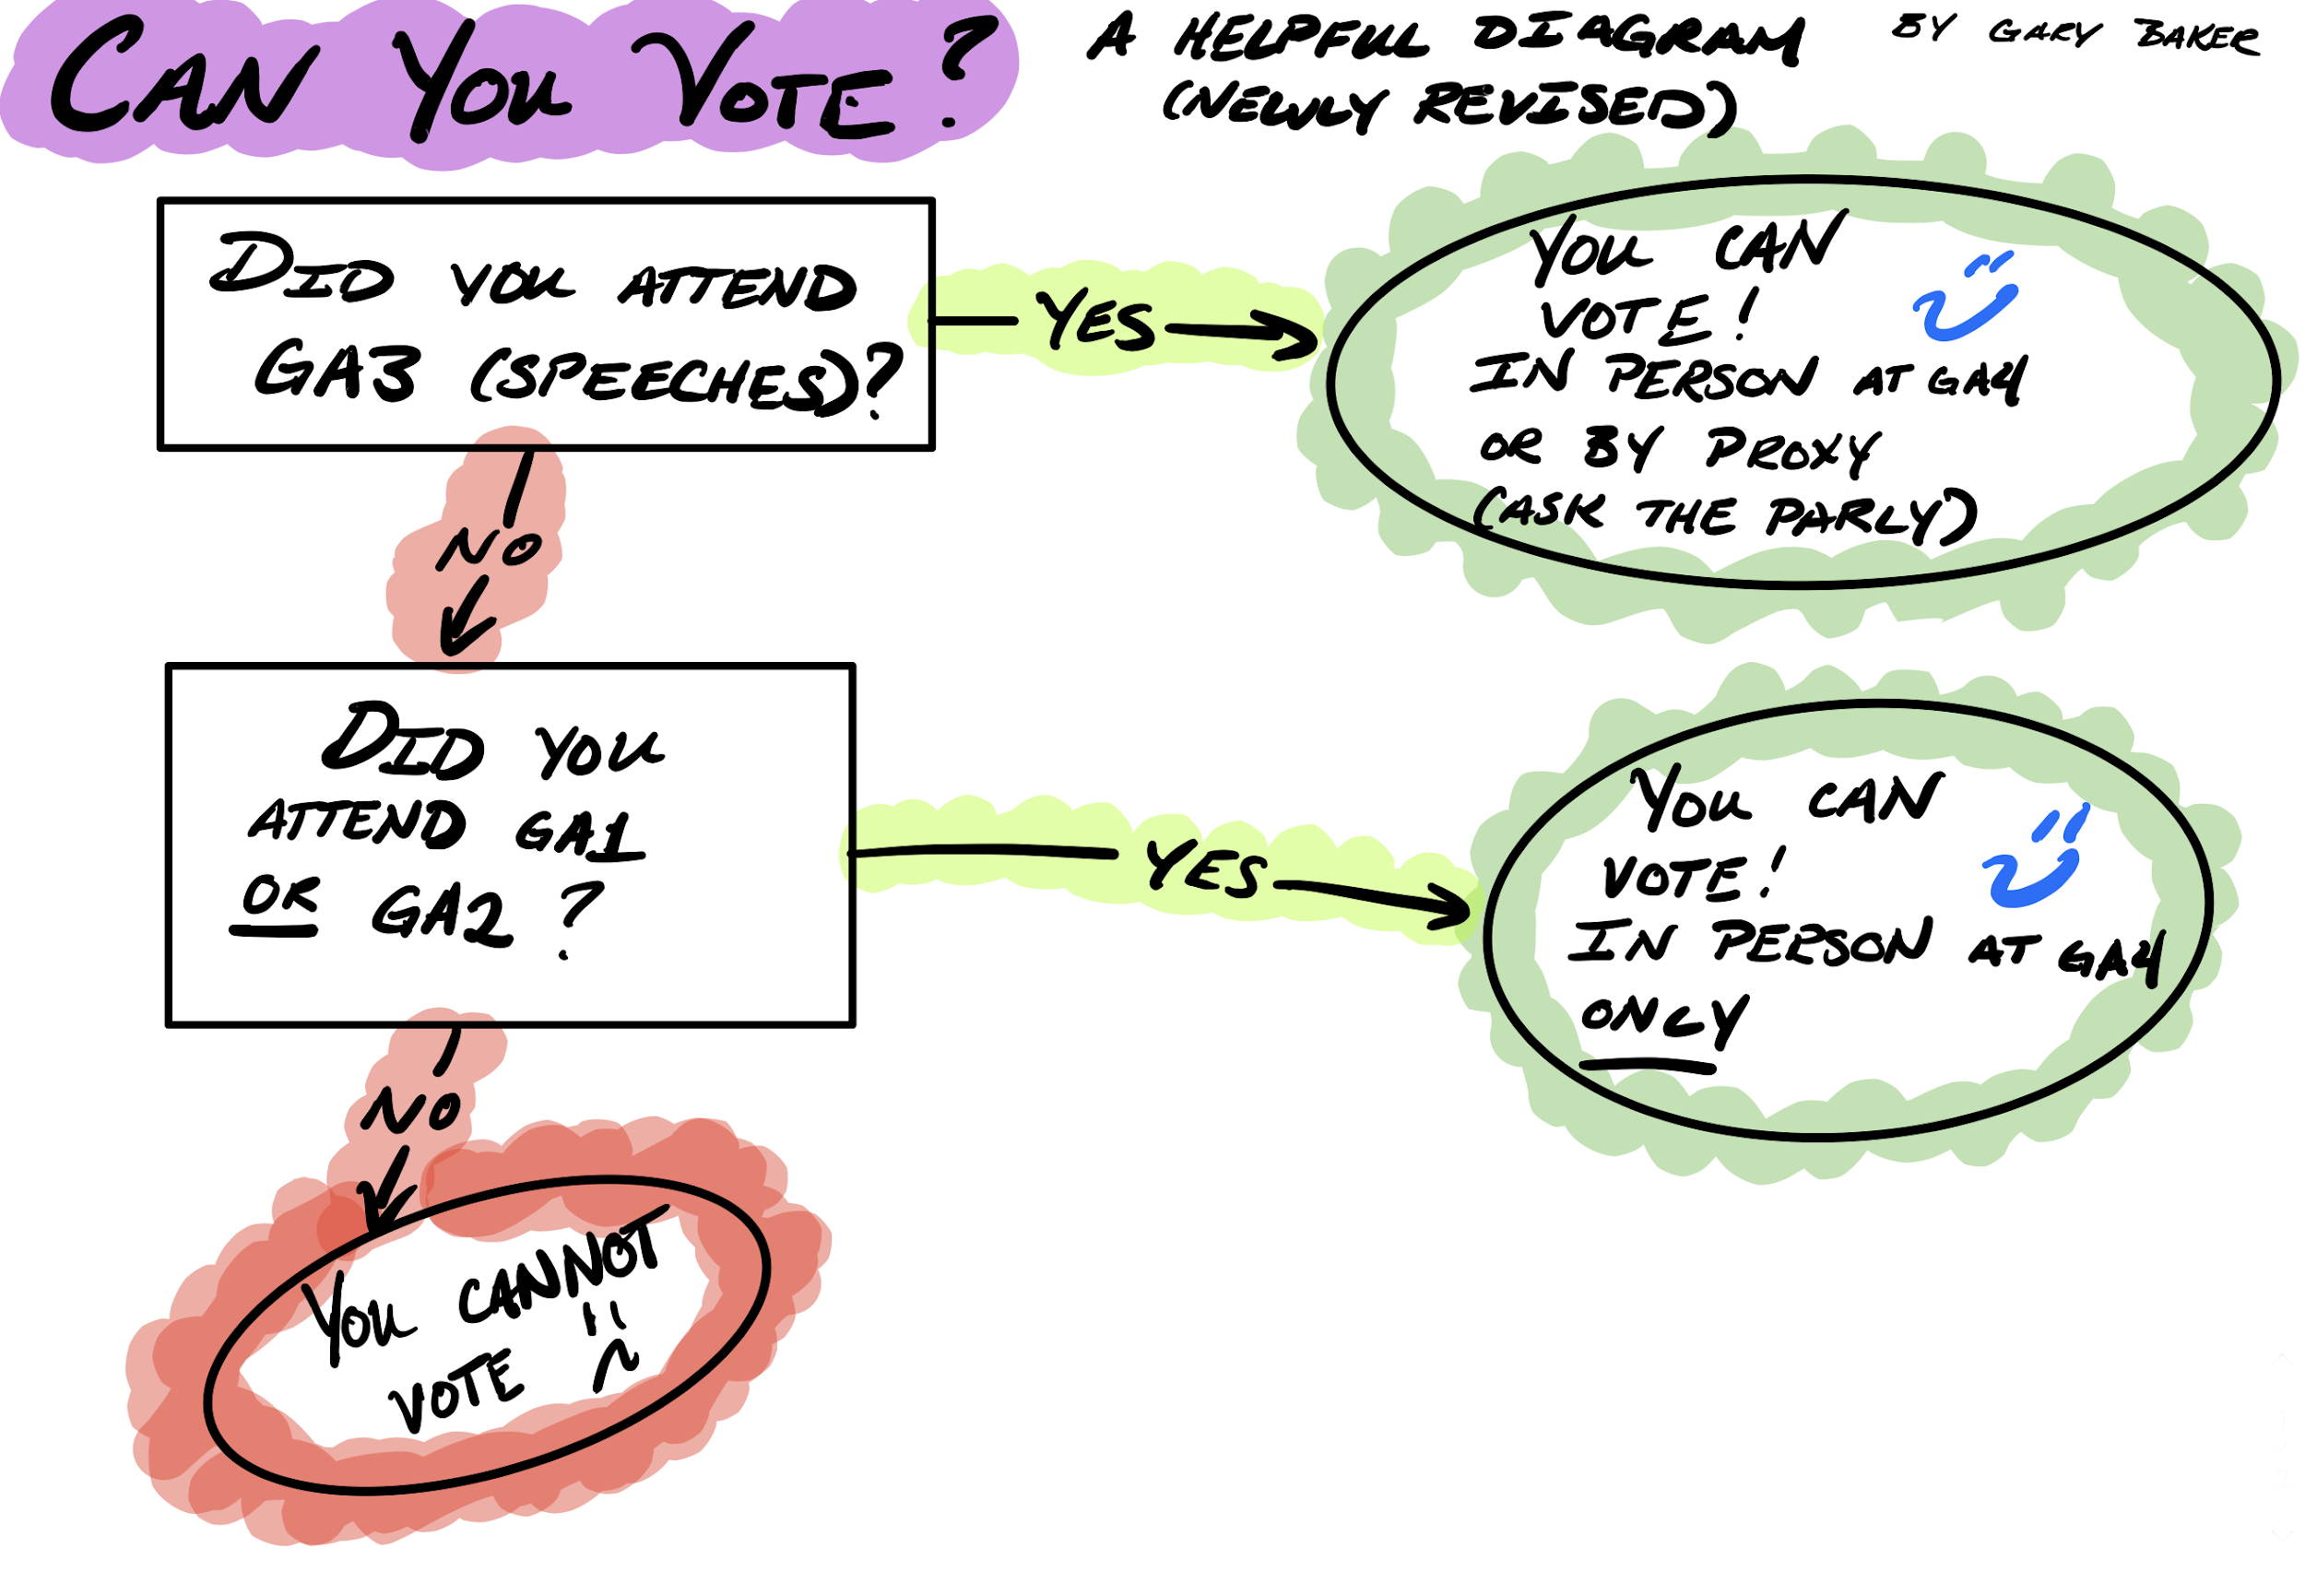
- Distribution of the ballot for amendments
- There is a link for the amendments being proposed in the master doc
- To vote: Must be registered for convention and must have paid dues (rather primary or associate)
- This link for voting will be available through tomorrow
- Eligible for candidates: must be a regular member next year (except President and Vice President must have attended a convention as a full SCLer)

Nominations
- Current officers discussed their duties on the board
- Procedure explained with nominations
- The floor is officially open for nominations
- President
  - Grace Weston (FL) moved to nominate Rachael Cox (FL) for President
- Vice President
  - Kristian Jackson (FL) moved to nominate Grace Weston (FL) for President
- Secretary
  - Jon Gumz (CA) moved to nominate Jordan John Lee (CA) for Vice President
- Treasurer
  - Daniel Newgarden (NJ) moved to nominate Raees Kamboj (NV) for Secretary
  - Drew Alvarez (LA) moved to nominate Sarah Lehman (LA) for Secretary
- Parliamentarian
  - Kashi Nikore (VA) moved to nominate Lexi Harrell (VA) for Parliamentarian

President | Vice President | Secretary | Treasurer | Parliamentarian
Rachael Cox | Grace Weston | Jordan John Lee | Raees Kamboj | Lexi Harrell
 |  |  | Sarah Lehman

- Floor is officially closed for nominations
- All candidates were given 4 minutes each for candidate speeches addressed to the members
- We will rejoin these candidates on Wednesday for Q&A session followed by voting
- Also please continue voting for the amendments, that will be open throughout the night into the next calendar day

Editor and Historian Applications are now live!
- Visit our master doc of links for the live application!
- Historian: https://forms.gle/bcPNrwZc12iLRSmo7
- Editor: https://forms.gle/tkN4KczzGV1mg18W7

Announcements
- Maddie Briner
  - Need one or two things for TE, but overall we look like we are in great shape for it and thank you to everyone!
- Elizabeth Foster
  - Voting for Superlatives is officially out!
- Kristian Jackson
  - Keep an eye out on the website for a super cool and fun scavenger hunt!
- Chris Rourke
  - We still need a lot of volunteers for that for Tuesday (tomorrow) at 5:30 - 8pm eastern
  - Reminder for the Publicity Committee is due at the end of day Wednesday!

- Shandi Burrows
  - Please stay around in this Zoom if you have a question about you voting rights or your status on paying dues

Meeting adjourned at 10:13 PM CST

