National Senior Classical League
General Assembly IV July 28, 2021

Meeting began at: Jamie called the meeting to order at 9:01 PM CST

Jamie read the guidelines for the zoom meeting.

Board Officers:
- Jamie Doyle, President
- Rachael Cox, Vice President
- Shandi Burrows, Secretary
- Natasha Panduwawala, Treasurer
- Neah Lekan, Parliamentarian
- Elizabeth Foster, Historian
- Ann Nguyen, Editor

Farm Theme GA’s: Tractor Facts of the Day, Jamie
- Lamborghini started as a tractor manufacturer!

Farmer(s) of the day:
- Liz Noone

Whizbangs, Shandi
- “Giving them seed usually puts them in love mode.” - Gary Baker
- “I like ‘em small.” - Jay Lee

Officer Reports
- Ann, Editor:
  - Thank you to everyone who stayed up late in the Ear Office last night!
  - Tonight is the last night in the Ear room! Please come by and make content/hangout!
- Elizabeth, Historian:
  - Please submit to the SCL Superlatives form in the Master Doc and the highlight video as well!
  - Worked on the SCL history today and shouted out many of the TE skits from last night!
- Neah, Parliamentarian:
  - Finished collecting all the votes on the amendments which will be announced later
  - And got everything ready for the elections tonight!
- Natasha, Treasurer:
  - Please remember to order t-shirts, those close as soon as convention ends!
  - Please visit the Redbubble, which will stay up after convention so you can buy gifts throughout the year!
- Shandi, Secretary:
  - Please use this link to make sure we have your updated membership info (only needs to be filled out once during convention)
  - Follow us on Instagram and Twitter @NationalSCL
- Rachael, Vice President:
  - Marathon, mystery test, and minecraft all went well! Thank you to all my O&L chairs this year!
- Jamie, President:
  - Please pay your dues so you can have voting rights tonight! Especially slashers!

Chair Reports, Rachael
- Trick-shot - Grace Weston
  - Went really well! Thank you to all the judges helping out with that!
- Website Committee, Chris Rourke
  - We extended the Website Committee Apps so please apply! You have until tomorrow morning now
- Ethics Committee, Joey Chatelain
  - Application form is live! Looking for a variety of memberships, just trying to make this the best environment we can for everyone
  - We also released a climate survey to see where we are and where we need to go, this can be found in the Slack and in the Master Doc

Amendment Vote Results
- All six propositions passed!
- These will go to the ACL board for a final ruling until these will become official

Elections
- 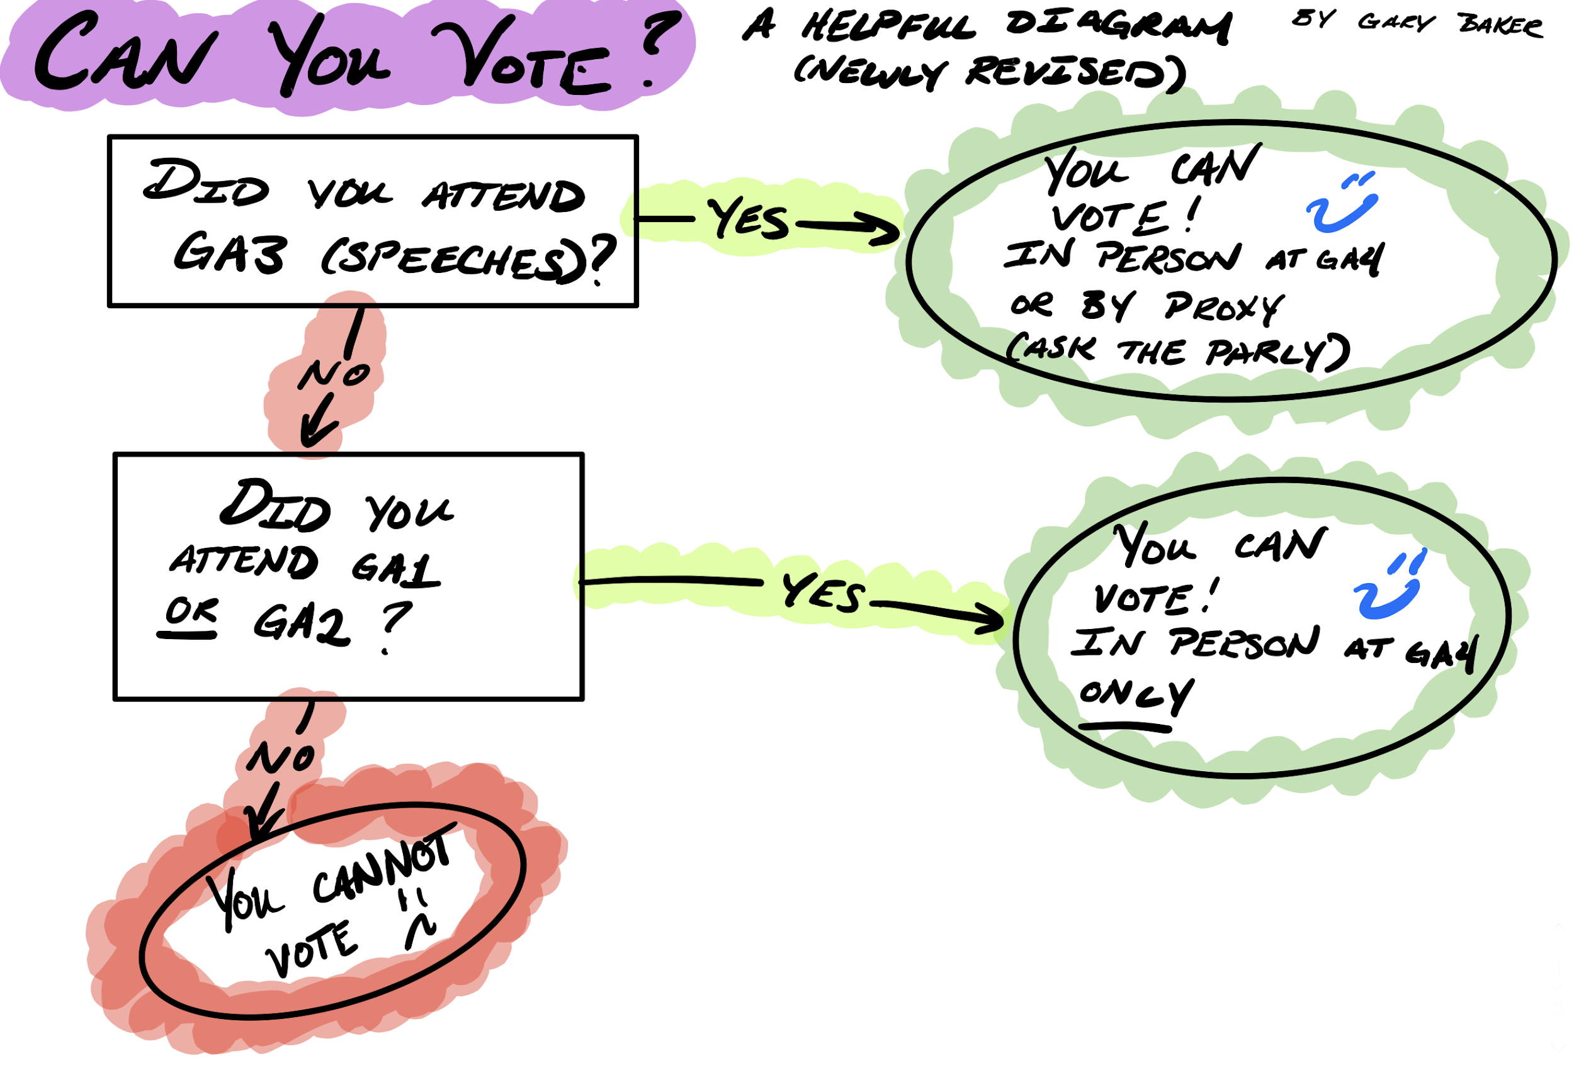
- Reminders: Eligibility for voting must be a primary or secondary member and have registered for convention/paid dues (as well as attended the GA’s according to the chart above) then you can vote!
- We will be voting without acclimation for positions that are uncontested as it arises

President | Vice President | Secretary | Treasurer | Parliamentarian
Rachael Cox | Grace Weston | Jordan John Lee | Raees Kamboj | Lexi Harrell
 |  |  | Sarah Lehman | Sarah Lehman dropped down to run in this position

- Voting
  - President - Q&A was dispensed and a vote of acclimation was passed to recognize Rachael Cox as President of the NSCL
  - Vice President - Q&A was dispensed and a vote of acclimation to recognize Grace Weston as Vice President of the NSCL
  - Secretary - Q&A was dispensed and a vote of acclimation was passed to recognize Jordan John Lee as Secretary of the NSCL
  - Treasurer - Q&A, open discussion, and voting commenced for this position. Voting resulted in an official tie, the current executive board joined together, and Raees Kamboj is officially elected as the NSCL Treasurer
  - Parliamentarian - Sarah Lehman dropped down to Parliamentarian after the results of the Treasurer election. Q&A , open discussion, and voting commenced for this position. Voting resulted in Lexi Harrell being officially elected as the NSCL Parliamentarian
  - Historian and Editor are application based and will be voted on by the new board tomorrow morning. Please Apply, applications are open until 6 AM Central

Scholarship Announcements, Kyle McGimsey
- Hal Rather Award, Member Scholarship, and Book award are all raised from donations from our members! Those winners are voted on by the board and announced after convention

Editor and Historian Application Reminders!
- Visit our master doc of links for the live applications due tomorrow morning!
- Historian: https://forms.gle/bcPNrwZc12iLRSmo7
- Editor: https://forms.gle/tkN4KczzGV1mg18W7

Announcements
- Joey Chatelain - Please consider applying to the ethics committee!
- Rachael Cox - Historian and Editor applicants will be notified of their interview times tomorrow morning
- Kristain Jackson - Please apply for Website Committee
- Elizabeth Foster - Please vote for Superlative and Highlight video
- Andrew Machkasov - Moved to adjourn

- Official SCL Officers for 2021-2022
  - President - Rachael Cox
  - Vice President - Grace Weston
  - Secretary - Jordan John Lee
  - Treasurer - Raees Kamboj
  - Parliamentarian - Lexi Harrell
  - Historian and Editor will be voted on by the newly elected board tomorrow!

Meeting adjourned at 10:29 PM CST

